**Bassett Mirror Company**

Website: <https://www.bassettmirror.com/category.cfm?catID=1>

#01

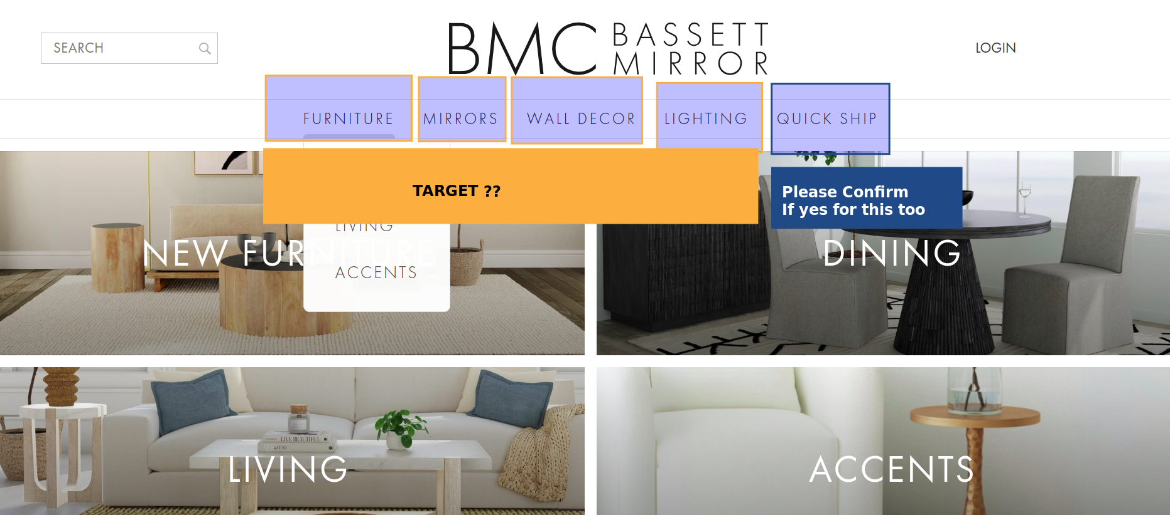

Targeting all these tabs

Response: Yes, target top nav values highlighted in yellow. Exclude Quick Ship.

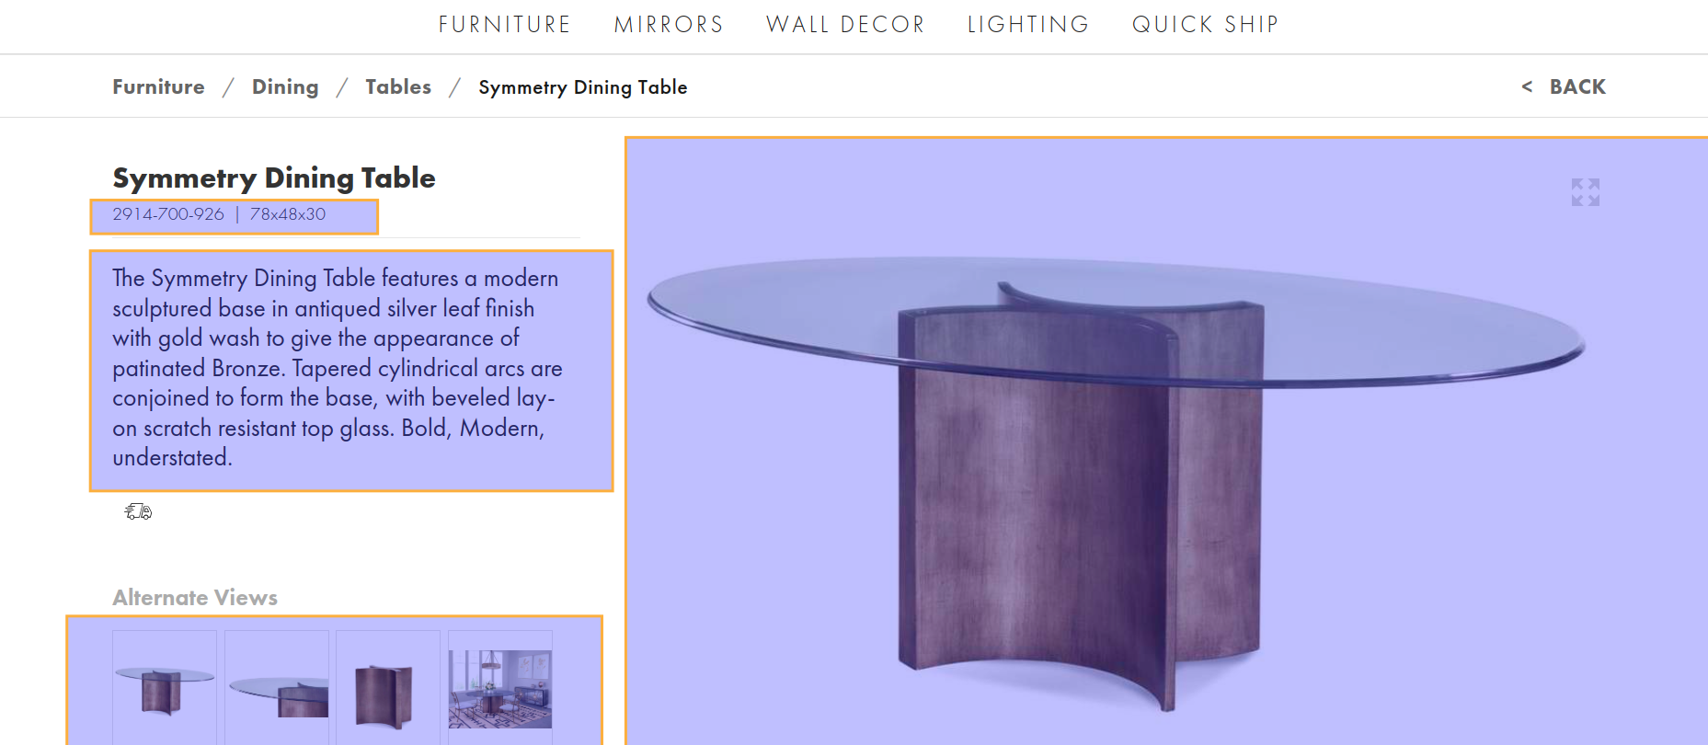

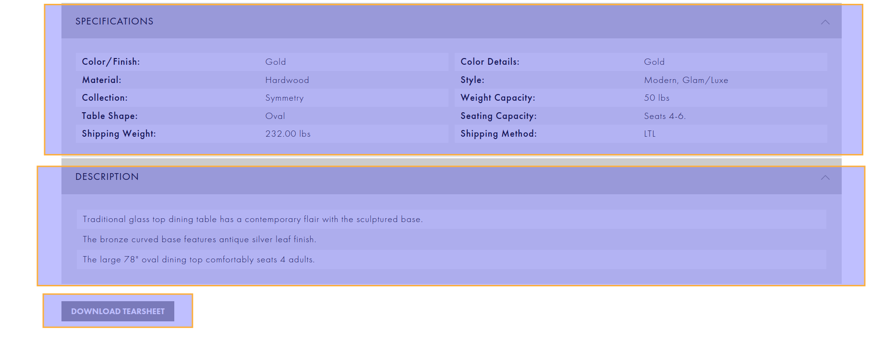

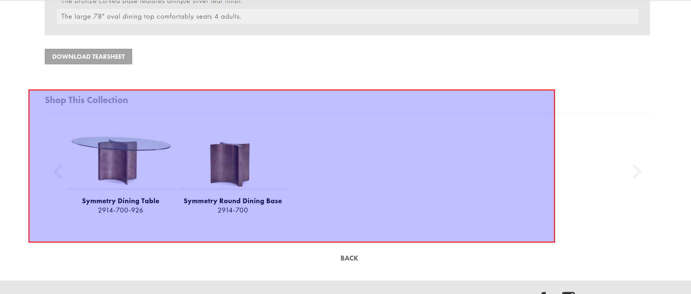

Response: Yes, pull all information highlighted in yellow. Exclude Shop This Collection.